Sample write-up of a mediation model
A mediation analysis was conducted using Model 4 of PROCESS to examine whether symptoms of post-traumatic stress (PTSS) mediate the relationship between exposure to violence and externalizing behavior in a sample of 1,605 children from the NSCAW I dataset. The analysis estimated the direct effect (c′), indirect effect (ab), total effect (c), and the proportion of the effect explained by mediation. A conceptual and statistical representation of the model is shown in Figure 1.
The first regression model examined whether exposure to violence predicted symptoms of post-traumatic stress. The model was significant, F(1,1603) = 98.38, p < .001, explaining 5.8% of the variance in PTSS (R² = .0578). A one-unit increase in violence exposure was associated with a 1.94-unit increase in PTSS symptoms (a = 1.9423, SE = 0.1958, p < .001), suggesting that greater exposure to violence corresponds to higher trauma symptoms. The standardized coefficient (β = 0.2405) indicates a moderate effect size, highlighting the strong relationship between violence exposure and PTSS.
The second regression model examined whether PTSS and violence exposure predict externalizing behavior. This model was significant, F(2,1602) = 16.66, p < .001, explaining 2.0% of the variance in externalizing behavior (R² = .0204). A one-unit increase in violence exposure was associated with a 0.82-unit increase in externalizing behavior (c′ = 0.8237, SE = 0.2267, p = .0003), though this effect was smaller than the total effect estimated in the initial model. A one-unit increase in PTSS was associated with a 0.10-unit increase in externalizing behavior (b = 0.0976, SE = 0.0281, p = .0005), indicating that higher PTSS levels correspond to greater externalizing behaviors. Standardized coefficients for both violence exposure (β = 0.0926) and PTSS (β = 0.0886) suggest small but meaningful effects of both variables on externalizing behavior.
The total effect of violence exposure on externalizing behavior was significant (c = 1.0133, SE = 0.2208, p < .001), meaning that higher violence exposure was associated with increased externalizing behaviors before accounting for trauma. This model explained 1.3% of the variance (R² = .0130).
The indirect effect of violence exposure on externalizing behavior through PTSS was significant (ab = 0.1896, BootSE = 0.0577, 95% CI: [0.0819, 0.3094]). The completely standardized indirect effect was β = 0.0213, 95% CI: [0.0091, 0.0349], indicating a small but statistically significant mediation effect.
To assess the proportion of the total effect explained by mediation, the indirect effect was divided by the total effect. The proportion of the total effect accounted for by trauma was 18.7% (0.1896 / 1.0133 = 0.187). This means that 18.7% of the relationship between violence exposure and externalizing behavior is explained by PTSS rather than being a direct effect.
These findings indicate that PTSS partially mediates the relationship between violence exposure and externalizing behavior. Although exposure to violence directly contributes to externalizing behaviors, a significant portion of this effect operates through PTSS, which amplifies externalizing tendencies. Since the direct effect remained significant, PTSS does not fully account for the relationship, suggesting partial mediation rather than full mediation.
These results highlight the critical role of trauma in shaping behavioral outcomes in children exposed to violence. Given that nearly one-fifth of the relationship between violence exposure and externalizing behavior is explained by PTSS, interventions targeting trauma symptoms may be an effective strategy for reducing externalizing behaviors in children with histories of violence exposure. Addressing PTSS in this population may help mitigate the adverse effects of violence on child behavioral development.
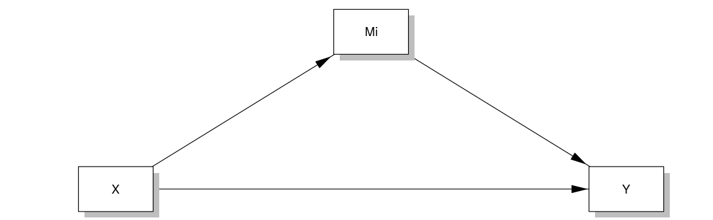
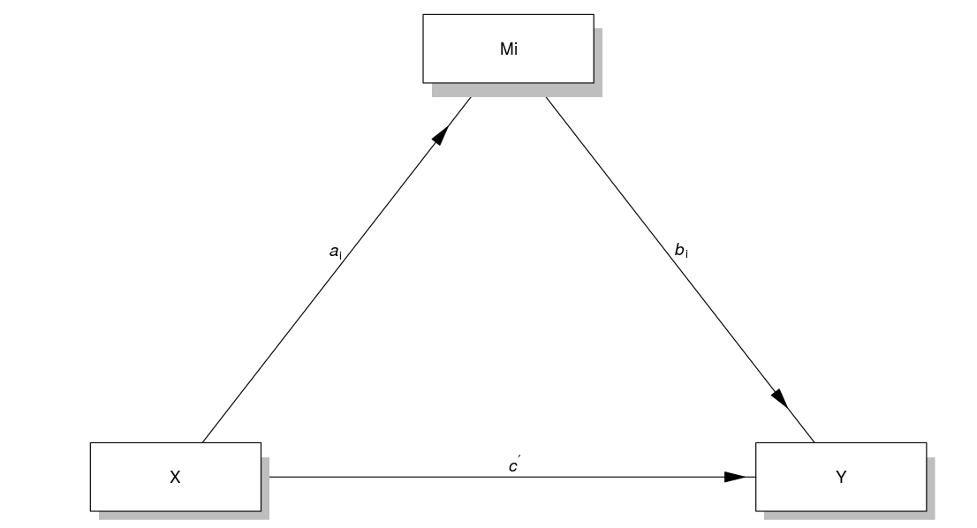
Figure 1. Mediation model. Conceptual (A) and Statistical (B). Ideally you would include meaningful variable names within the boxes (i.e., Violence Exposure = X). I am lazy. Also, in real life no need to show both. The conceptual and statistical model are the same for this mediation model. More later.

